1. **Recognize the main AWS service categories and core services**
2. **Recognize the main AWS service categories and core services**
3. **Describe six advantages of cloud computing**
4. **Define different types of cloud computing models**

**Objectives**

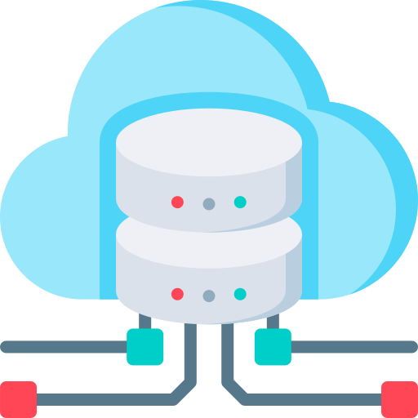

Prepared by

Niraj Surve

**AWS Academy: Cloud Foundations**

**Module 1: Cloud Concepts Overview**

**Section 1: Intro to Cloud Computing**

**Cloud Computing:**

* The on-demand delivery of compute power, database, storage, applications, and other IT resources via the internet with pay-as-you-go pricing.
* Cloud computing enables you to stop thinking of infrastructure as hardware, and instead think of (and use) it as software.

**Traditional Computing Model:**

* Infrastructure as Hardware.
* Hardware solutions: Require space, staff, physical security, planning, capital expenditure
* Having a long hardware procurement cycle
* Require you to provision capacity by guessing theoretical maximum peaks

**Cloud Computing Model:**

* Infrastructure as Software.
* Software solutions:

1. Flexible
2. Can change more quickly, easily and cost-effectively than hardware solutions
3. Eliminate the undifferentiated heavy-lifting tasks

**Cloud service models vary on how much control you have over IT resources.**

* Infrastructure as a Service (IaaS) - Most control
* Platform as a Service (PaaS)
* Software as a Service (SaaS) - Least control

**Cloud computing deployment models**

1. Cloud
2. Hybrid
3. On-premise (Private Cloud)

**Cloud computing can do almost anything the traditional IT can do.**